LAB EXPERIMENTS – ITA04 STATISTICS WITH R PROGRAMMING

- Create numeric, character, and logical vectors and display type and content.

Program:

# Numeric vector
num <- c(10, 20, 30)

# Character vector
char <- c("A", "B", "C")

# Logical vector
logi <- c(TRUE, FALSE, TRUE)

print(num)
print(typeof(num))

print(char)
print(typeof(char))

print(logi)
print(typeof(logi))

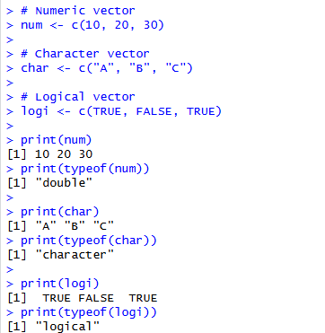
output:

2. Create labeled matrices (5×4, 3×3, 2×2) filled by row/column
Program
# 5×4 matrix (filled by row)
m1 <- matrix(1:20, nrow=5, ncol=4, byrow=TRUE)
rownames(m1) <- c("R1","R2","R3","R4","R5")
colnames(m1) <- c("C1","C2","C3","C4")

print(m1)

# 3×3 matrix (filled by column)
m2 <- matrix(1:9, nrow=3, byrow=FALSE)
rownames(m2) <- c("A","B","C")
colnames(m2) <- c("X","Y","Z")

print(m2)

# 2×2 matrix
m3 <- matrix(1:4, nrow=2, byrow=TRUE)
rownames(m3) <- c("R1","R2")
colnames(m3) <- c("C1","C2")

print(m3)

output:

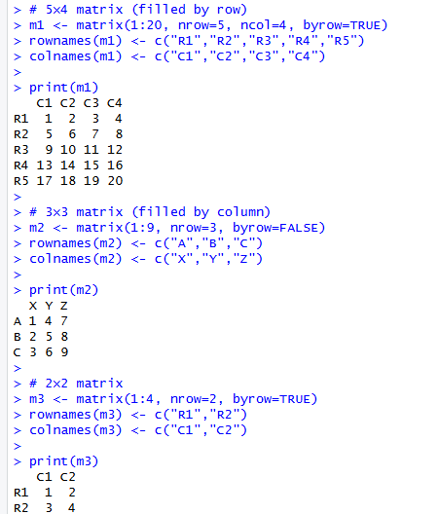

3. Create and display a 3D array
Program
arr <- array(1:24, dim=c(2,3,4))
print(arr)

output:
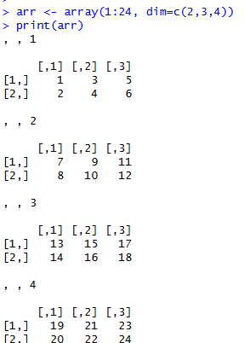

4. Create arrays with dimension names and print a specific element
Program
v <- 1:12

arr <- array(v,
dim=c(2,3,2),
dimnames=list(
Row=c("R1","R2"),
Col=c("C1","C2","C3"),
Table=c("T1","T2")
))

print(arr)

print(arr["R2","C3","T2"])

output:
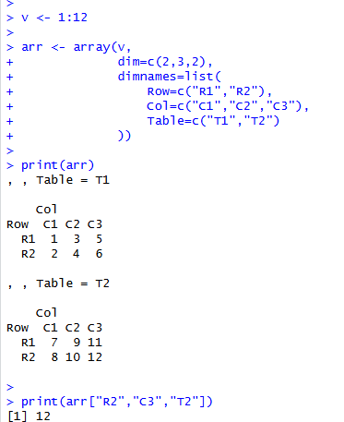

5. Create and manipulate factor variables
Program
heights <- factor(c("Short","Medium","Tall","Medium","Tall"))

print(heights)
print(levels(heights))

letters_factor <- factor(sample(LETTERS[1:5],10,replace=TRUE))

print(letters_factor)
summary(letters_factor)

output:

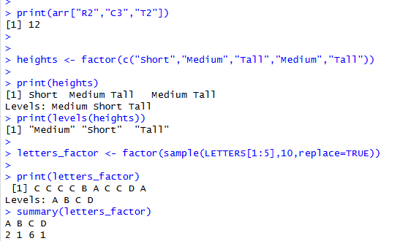

6. Create an R list containing vectors, matrices and functions
Program
vec <- c(1,2,3)

mat <- matrix(1:4,2,2)

mylist <- list(
Vector=vec,
Matrix=mat,
Function=sum
)

print(mylist)

mylist$Function(vec)

output:

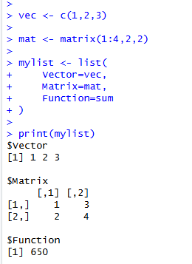

7. Write R programs for basic tasks: Factors of a number, generate a vector of 10 random integers
between -50 and 50, print numbers 1–100 with FizzBuzz logic.

(a). Find factors of a number
Program
num <- 24

for(i in 1:num)
{
if(num %% i == 0)
print(i)
}
Output:

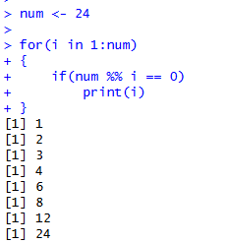

(b). Generate 10 random integers between -50 and 50
Program
set.seed(100)

x <- sample(-50:50,10)

print(x)

output:
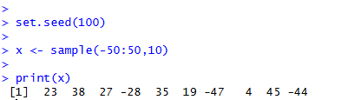

(c). FizzBuzz (1 to 100)
Program
for(i in 1:100)
{
if(i %% 3 == 0 && i %% 5 == 0)
print("FizzBuzz")
else if(i %% 3 == 0)
print("Fizz")
else if(i %% 5 == 0)
print("Buzz")
else
print(i)
}

Output:
